CASE STUDY


TEAM BY:TECH TITAN’S
R.SUPRIYA (25311A05FF)
A.SRINESH (25311A05FE)
N.SHRAVYA (25311A05EW)

Guided By:
B. Vijay Kumar
📚 Library Management System:

Introduction:
Data Structures are methods of organizing and storing data so that it can be accessed and modified efficiently. They are widely used in real-world applications such as banking systems, libraries, databases, and operating systems.
A Library Management System is used to maintain records of books, issue books to users, and track returned books. In traditional libraries, managing books manually is difficult and time-consuming.
This project uses several Data Structure concepts:
- Doubly Linked List → To store and manage book records
- Queue → To manage the waiting list for books
- Stack → To store recently returned books
- File Handling → To store book data permanently
- This system helps in efficient management of books, reduces manual work, and makes searching and updating records faster.

PROBLEM STATEMENT:
In many small libraries, books are managed manually using registers. This causes several problems:
Difficult to track book availability
Hard to manage waiting lists
Risk of losing records
Slow searching of books
Therefore, a Library Management System using Data Structures is required to efficiently manage book records and user requests.

Objectives:
The main objectives of this project are:
- To add and store book details
- To issue books to users
- To return books and update availability
- To manage waiting list using queue
- To store data using file handling
- To demonstrate the use of Linked List, Queue, and Stack
Benefits of the system:
- Easy book management
- Faster data access
- Reduced manual errors
- Efficient record storag
- Literature Review
- Several library systems already exist using different technologies.

Some systems use:
Database Management Systems
Web applications
Cloud storage
However, these systems can be complex and require advanced infrastructure.
This project focuses on implementing basic Data Structures concepts in C language, which helps students understand how real-world systems use data structures.

Advantages:
Simple implementation
Good for learning DSA concepts
Efficient data handling.

Limitations:
No graphical interface
Limited security
System Design:
1.Algorithms
Algorithm for Adding Book
Start
Enter book ID and book name
Create new node
Insert node in doubly linked list
Save data to file
Display success message
Stop

Algorithm for Issuing Book:
Start
Enter book ID
Search book in list
If available → issue book
If not available → add user to waiting queue
Display message
Stop

Algorithm for Returning Book:
Start
Enter book ID
Update availability
Add book to stack (recently returned)
If queue not empty → issue to next user
Display message
Stop

2. Flowcharts:
Flowchart illustrating the process of a Library Management System.
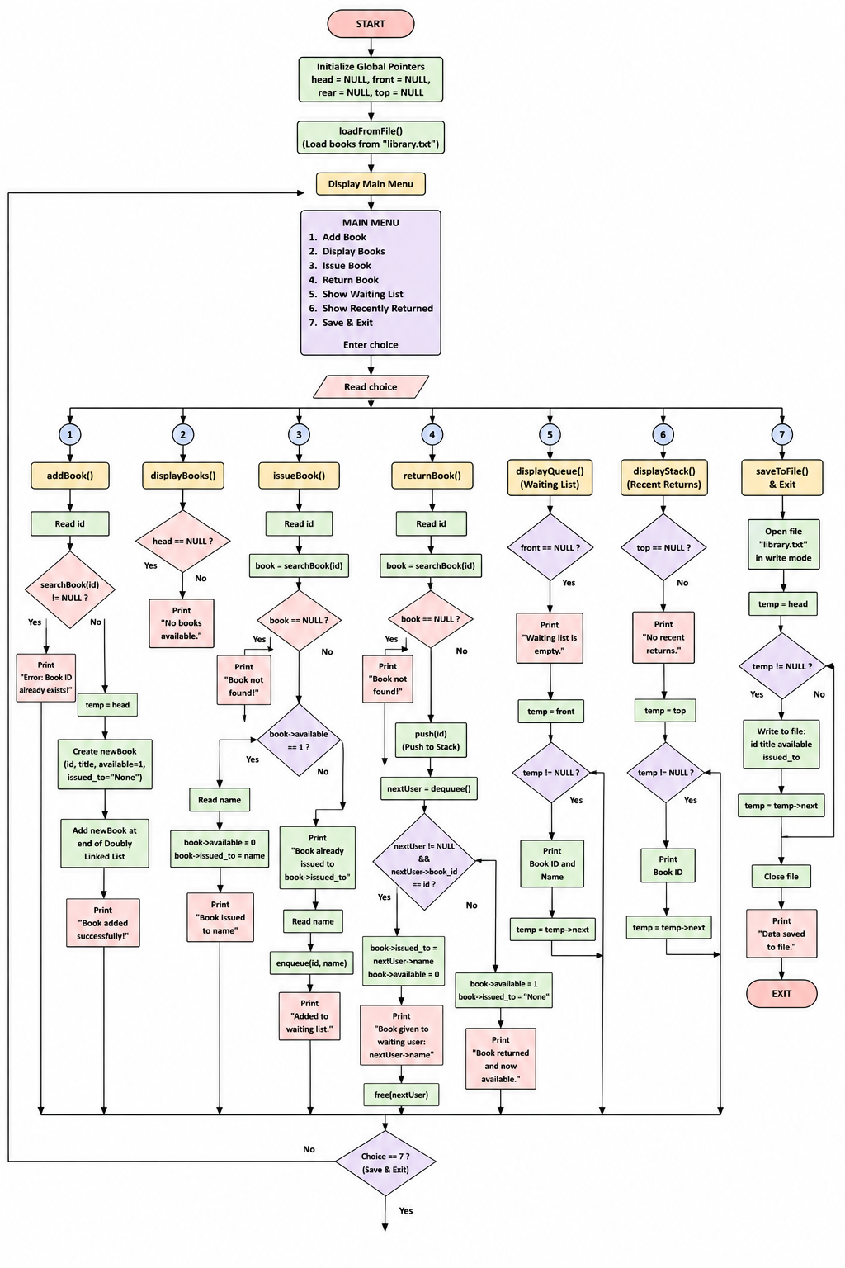
Implementation:
The project is implemented using C programming language.
Concepts Used:
- Structures
- Doubly Linked List
- Queue
- Stack
- File Handling
- Functions
Advantages:
Simple implementation
Good for learning DSA concepts
Efficient data handling.

Code:
#include <stdio.h>
#include <stdlib.h>
#include <string.h>

// ----------- BOOK STRUCT -----------
typedef struct Book {
int id;
char title[50];
int available;
char issued_to[50];
struct Book *prev, *next;
} Book;

Book *head = NULL;

// ----------- QUEUE (WAITING LIST) -----------
typedef struct Queue {
int book_id;
char name[50];
struct Queue *next;
} Queue;

Queue *front = NULL, *rear = NULL;

// ----------- STACK (RECENT RETURNS) -----------
typedef struct Stack {
int book_id;
struct Stack *next;
} Stack;

Stack *top = NULL;

// ----------- SEARCH BOOK -----------
Book* searchBook(int id) {
Book *temp = head;
while (temp) {
if (temp->id == id)
return temp;
temp = temp->next;
}
return NULL;
}

// ----------- ADD BOOK (WITH DUPLICATE CHECK) -----------
void addBook() {
int id;
char title[50];

printf("Enter Book ID: ");
scanf("%d", &id);

// Prevent duplicate ID
if (searchBook(id) != NULL) {
printf("Error: Book ID already exists!\n");
return;
}

printf("Enter Title: ");
scanf(" %[^\n]", title);

Book *newBook = (Book*)malloc(sizeof(Book));
newBook->id = id;
strcpy(newBook->title, title);
newBook->available = 1;
strcpy(newBook->issued_to, "None");

newBook->next = newBook->prev = NULL;

if (head == NULL) {
head = newBook;
} else {
Book *temp = head;
while (temp->next)
temp = temp->next;

temp->next = newBook;
newBook->prev = temp;
}

printf("Book added successfully!\n");
}

// ----------- DISPLAY BOOKS -----------
void displayBooks() {
if (head == NULL) {
printf("No books available.\n");
return;
}
Book *temp = head;
printf("\n--- BOOK LIST ---\n");
while (temp) {
printf("ID: %d | Title: %s | Status: %s",
temp->id,
temp->title,
temp->available ? "Available" : "Issued");

if (!temp->available) {
printf(" | Issued To: %s", temp->issued_to);
}

printf("\n");
temp = temp->next;
}
}
// ----------- QUEUE FUNCTIONS -----------
void enqueue(int id, char name[]) {
Queue *newNode = (Queue*)malloc(sizeof(Queue));
newNode->book_id = id;
strcpy(newNode->name, name);
newNode->next = NULL;

if (rear == NULL) {
front = rear = newNode;
} else {
rear->next = newNode;
rear = newNode;
}
}
Queue* dequeue() {
if (front == NULL)
return NULL;
Queue *temp = front;
front = front->next;

if (front == NULL)
rear = NULL;
return temp;
}

// ----------- STACK FUNCTIONS -----------
void push(int id) {
Stack *newNode = (Stack*)malloc(sizeof(Stack));
newNode->book_id = id;
newNode->next = top;
top = newNode;
}

// ----------- ISSUE BOOK -----------
void issueBook() {
int id;
char name[50];

printf("Enter Book ID: ");
scanf("%d", &id);

Book *book = searchBook(id);

if (book == NULL) {
printf("Book not found!\n");
return;
}

if (book->available) {
printf("Enter your name: ");
scanf(" %[^\n]", name);

book->available = 0;
strcpy(book->issued_to, name);

printf("Book issued to %s\n", name);
} else {
printf("Book already issued to %s\n", book->issued_to);

printf("Enter your name for waiting list: ");
scanf(" %[^\n]", name);

enqueue(id, name);
printf("Added to waiting list.\n");
}
}

// ----------- RETURN BOOK -----------
void returnBook() {
int id;

printf("Enter Book ID to return: ");
scanf("%d", &id);

Book *book = searchBook(id);

if (book == NULL) {
printf("Book not found!\n");
return;
}

push(id);

Queue *nextUser = dequeue();

if (nextUser != NULL && nextUser->book_id == id) {
strcpy(book->issued_to, nextUser->name);
printf("Book given to waiting user: %s\n", nextUser->name);
free(nextUser);
book->available = 0;
} else {
book->available = 1;
strcpy(book->issued_to, "None");
printf("Book returned and now available.\n");
}
}

// ----------- DISPLAY WAITING LIST -----------
void displayQueue() {
if (front == NULL) {
printf("Waiting list is empty.\n");
return;
}

Queue *temp = front;

printf("\n--- WAITING LIST ---\n");

while (temp) {
printf("Book ID: %d | Name: %s\n",
temp->book_id,
temp->name);
temp = temp->next;
}
}

// ----------- DISPLAY STACK -----------
void displayStack() {
if (top == NULL) {
printf("No recent returns.\n");
return;
}

Stack *temp = top;

printf("\n--- RECENT RETURNS ---\n");

while (temp) {
printf("Book ID: %d\n", temp->book_id);
temp = temp->next;
}
}

// ----------- SAVE FILE -----------
void saveToFile() {
FILE *fp = fopen("library.txt", "w");

Book *temp = head;

while (temp) {
fprintf(fp, "%d %s %d %s\n",
temp->id,
temp->title,
temp->available,
temp->issued_to);
temp = temp->next;
}

fclose(fp);
printf("Data saved to file.\n");
}

// ----------- LOAD FILE -----------
void loadFromFile() {
FILE *fp = fopen("library.txt", "r");
if (fp == NULL) return;

while (1) {
Book *newBook = (Book*)malloc(sizeof(Book));

if (fscanf(fp, "%d %[^\n] %d %[^\n]",
&newBook->id,
newBook->title,
&newBook->available,
newBook->issued_to) != 4) {
free(newBook);
break;
}

newBook->next = newBook->prev = NULL;

if (head == NULL) {
head = newBook;
} else {
Book *temp = head;
while (temp->next)
temp = temp->next;

temp->next = newBook;
newBook->prev = temp;
}
}

fclose(fp);
}

// ----------- MAIN -----------
int main() {
int choice;

loadFromFile();

while (1) {
printf("\n--- LIBRARY MENU ---\n");
printf("1. Add Book\n");
printf("2. Display Books\n");
printf("3. Issue Book\n");
printf("4. Return Book\n");
printf("5. Show Waiting List\n");
printf("6. Show Recently Returned\n");
printf("7. Save & Exit\n");

printf("Enter choice: ");
scanf("%d", &choice);

switch (choice) {
case 1: addBook(); break;
case 2: displayBooks(); break;
case 3: issueBook(); break;
case 4: returnBook(); break;
case 5: displayQueue(); break;
case 6: displayStack(); break;
case 7: saveToFile(); exit(0);
default: printf("Invalid choice!\n");
}
}
return 0;
}
OUT PUT:
--- LIBRARY MENU ---
1. Add Book
2. Display Books
3. Issue Book
4. Return Book
5. Show Waiting List
6. Show Recently Returned
7. Save & Exit
Enter choice: 1
Enter Book ID: 201
Enter Title: THE ART OF BEING ALONE
Book added successfully!

--- LIBRARY MENU ---
1. Add Book
2. Display Books
3. Issue Book
4. Return Book
5. Show Waiting List
6. Show Recently Returned
7. Save & Exit
Enter choice: 2

--- BOOK LIST ---
ID: 201 | Title: THE ART OF BEING ALONE | Status: Available

--- LIBRARY MENU ---
1. Add Book
2. Display Books
3. Issue Book
4. Return Book
5. Show Waiting List
6. Show Recently Returned
7. Save & Exit
Enter choice: 3
Enter Book ID: 201
Enter your name: THE ART BEING ALONE
Book issued to THE ART BEING ALONE

--- LIBRARY MENU ---
1. Add Book
2. Display Books
3. Issue Book
4. Return Book
5. Show Waiting List
6. Show Recently Returned
7. Save & Exit
Enter choice: 5
Waiting list is empty.

--- LIBRARY MENU ---
1. Add Book
2. Display Books
3. Issue Book
4. Return Book
5. Show Waiting List
6. Show Recently Returned
7. Save & Exit
Enter choice: 3
Enter Book ID: 201
Book already issued to THE ART BEING ALONE
Enter your name for waiting list: SRI
Added to waiting list.

--- LIBRARY MENU ---
1. Add Book
2. Display Books
3. Issue Book
4. Return Book
5. Show Waiting List
6. Show Recently Returned
7. Save & Exit
Enter choice: 5

--- WAITING LIST ---
Book ID: 201 | Name: SRI

--- LIBRARY MENU ---
1. Add Book
2. Display Books
3. Issue Book
4. Return Book
5. Show Waiting List
6. Show Recently Returned
7. Save & Exit
Enter choice: 4
Enter Book ID to return: 201
Book given to waiting user: SRI

--- LIBRARY MENU ---
1. Add Book
2. Display Books
3. Issue Book
4. Return Book
5. Show Waiting List
6. Show Recently Returned
7. Save & Exit
Enter choice: 7
Segmentation fault
=== Code Exited With Errors ===

Output Screenshots:

Results:
The program successfully performs:
Adding books
Issuing books
Returning books
Managing waiting list
Storing data in file

Conclusion:
The Library Management System was successfully developed using C programming and Data Structures to manage library operations efficiently. This project demonstrates the implementation of Doubly Linked Lists for book management, Queue for waiting lists, Stack for recent returns, and File Handling for storing data permanently. The system simplifies book management processes such as adding, issuing, returning, and displaying books, reducing manual work and improving efficiency. It provides a practical understanding of data structures and their real-world applications in software development.

